**How to clone an existing repository in local PC**

Contents

Go to your local drive path 1

Write cmd in address bar 2

Go to Github 2

Go to project 🡪 Click “Code” and copy the repository url 3

Go to command prompt 3

Repository will copy in your local machine 3

## Go to your local drive path

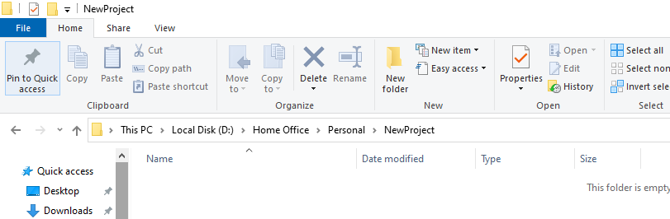

## Write cmd in address bar

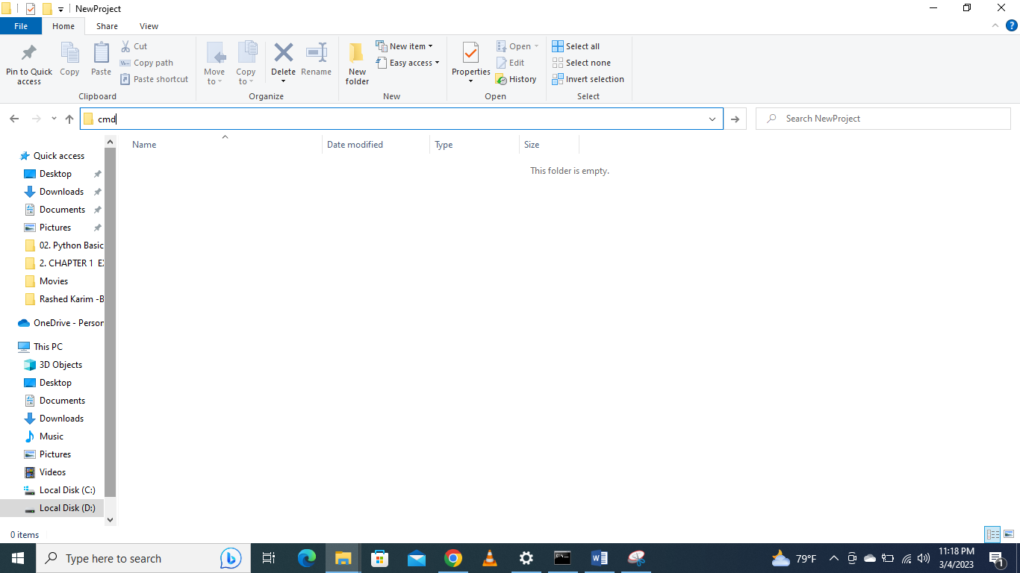

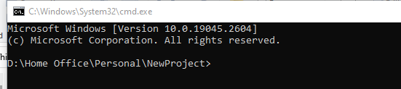

## Go to Github



## Go to project 🡪 Click “Code” and copy the repository url

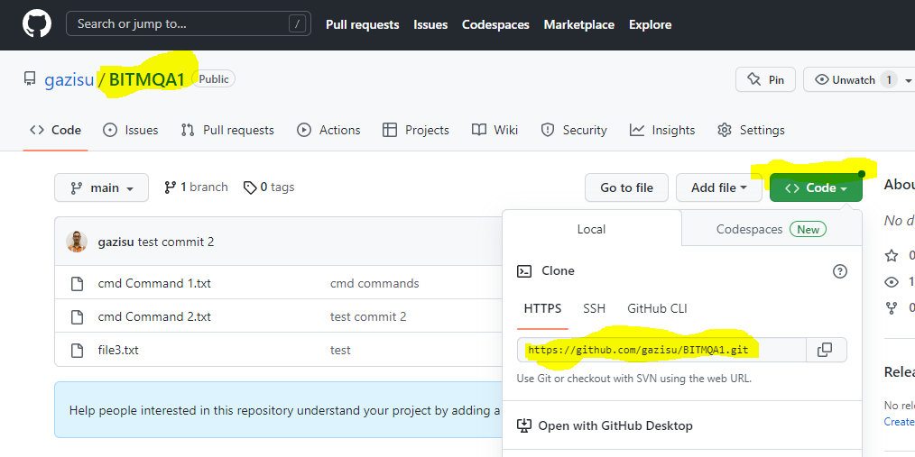

## Go to command prompt

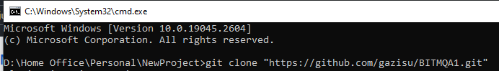

## Repository will copy in your local machine

